Name: Vincent Tuason
L#: (I do not know what this is)
Project Title: Heart Rate monitor using Pulse Sensor + BLE + Phone/PC

Problem Statement:
Why are you doing this?

I chose this project because I was curious how a heart rate monitor worked. I have a lot of family members who use a blood pressure monitor with integrated heart rate monitors. I initially thought about doing a blood pressure monitor but after looking at the available projects I decided to go with this one.

Objectives:
What are you trying to prove/do?
I am trying to measure an individual’s heart rate and graph their raw pulse onto a plot. I will also try and calculate how many times their heart beats in a span of 60 seconds.

Design Steps:
How do you implement X? What are the steps to do X?
Step 1: Read signal from Pulse sensor using ADC
Step 2: Check if the pulse is legitimate by comparing it to the threshold value, if the reading is good, increment the beat counter
Step 3: The results that will be presented will be the individual’s raw pulse, pulse graph, and BPM (Beats per Minute).

Timeline:
Breakdown in Weeks

04/22/2018 – 04/28/2018
Successfully displayed the data on the UART terminal

05/01/2018 – 05/08/2018
Successfully transmitted the data via Bluetooth
Fulfilled all submission guidelines

Hardware Components:
Xplained Mini
HC06 Serial Bluetooth Brick
Pulse Sensor
LED block
A lot of wires
Micro usb connector to power the Xplained Mini

Initial Schematics:
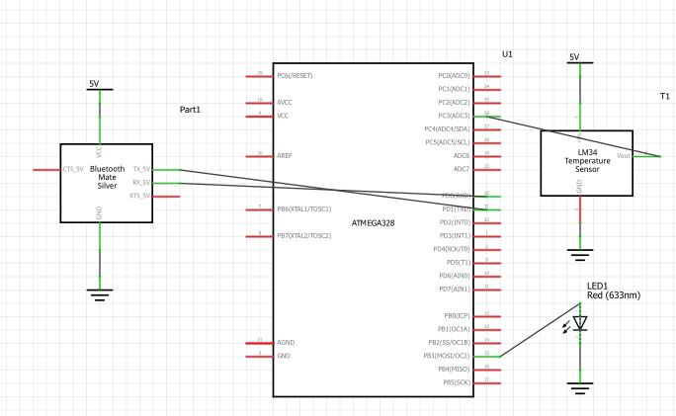

Reference:

ATMega328P Complete Datasheet:

http://ww1.microchip.com/downloads/en/DeviceDoc/Atmel-42735-8-bit-AVR-Microcontroller-ATmega328-328P_Datasheet.pdf

Pulse Sensor Datasheet:

https://cdn.shopify.com/s/files/1/0100/6632/files/Pulse_Sensor_Data_Sheet.pdf?14358792549038671331

